**CIS 229 – Python Programming – Programming Assignment**

**Hello World**

Overview

In this assignment, the student will write a “Hello World” and “Introduction” script.

When completing this assignment, the student should demonstrate mastery of the following concepts:

* Basic Interpreter Usage
* Simple Output
* Simple Variables
* Packaging a Script Deliverable

Assignment

Write a Python script that displays the text “Hello World” on the console. In addition to that, write a script that displays your full name, age, and a sentence summarizing any past programming experience you have. After you have written your scripts, “zip” them together in the same file and submit.

Example Screen Shot #1

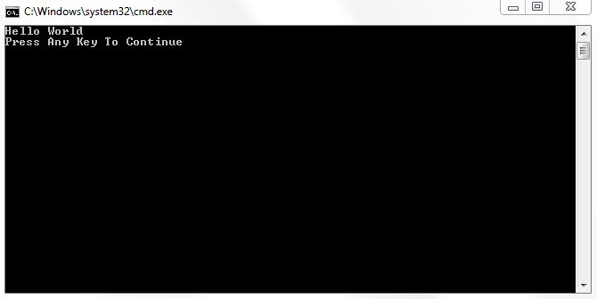

Assessment

This assignment will be assessed based on the provided grading rubric.